Business Requirements Document(BRD) Template
Project/Initiative
Month 20YY
Version X.XX

Company Information

Document Revisions
Date | Version Number | Document Changes
05/02/20xx | 0.1 | Initial Draft

Approvals
Role | Name | Title | Signature | Date
Project Sponsor
Business Owner
Project Manager
System Architect
Development Lead
User Experience Lead
Quality Lead
Content Lead

Introduction

Project Summary

Objectives
- Remove the barriers preventing the purchase from being completed.
- Provide fast and easy payment methods (Apple Pay, Google Pay, card).
- Make booking confirmation available immediately after payment.
- Handle payment errors without losing the booking

Background
Business wants to improve user experience and increase successful bookings.

Business Drivers
- Increase number of completed bookings.
- Reduce abandoned bookings.
- Improve payment experience.

Project Scope

In Scope Functionality
- Room selection.
- Display of booking details before payment.
- Display of full price calculation.
- Display of cancellation policy.
- Display of included services (e.g., breakfast included).
- Payment methods: Apple Pay, Google Pay, credit/debit card and Pay at Hotel
- Integration with a payment service provider (Stripe).
- Payment processing.
- Booking confirmation after successful payment.
- Booking display in the user account.
- PDF receipt sent by email.
- Automatic notifications for successful and failed payments.
- Payment error handling.
- Payment retry within 15 minutes after failure.
- Temporary room reservation during payment retry period.

Out of Scope Functionality
- Discounts system redesign
- Travel insurance
- Any functionality not explicitly listed in the In Scope section.

System Perspective

Assumptions
- Users have internet connection
- Payment providers work correctly
- Hotels confirm availability in system
- Email system works

Constraints
- The system must not store CVV codes.
- The system must fully follow PCI DSS security standards.
- User data must be encrypted to keep it safe.

Risks
- Payment can fail
- Internet connection can drop
- Room can be booked by another user if system fails
- Email confirmation can be delayed

Issues
- Some users may leave the booking process because the price is not clear early enough.

Business Process Overview
[Describe how the current process(es) work, including the interactions between systems and various business units. Include visual process flow diagrams to further illustrate the processes the new product will replace or enhance.
Use case documentation and accompanying activity or process flow diagrams can be used to create the description(s) of the proposed or “To-Be” processes.]

Current Business Process (As-Is)
At any point during or after deployment of web apps or web sites (internal or external) to support business activities, development/support teams may create and deploy widgets.
- CMS / database administrators for the employee portal use the CMS tool to create widgets. They can test widgets in the designated staging environment, then register them and deploy to production.
- Development teams may deploy widgets to development and testing environments set up for their development projects. They must check widget code into and out of the source code repository according to their projects’ development schedule.
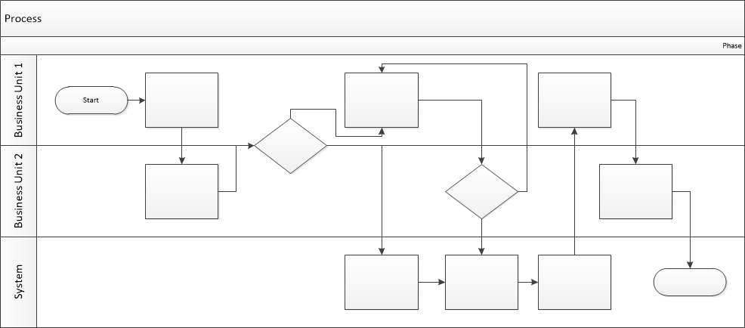

Proposed Business Process (To-Be)
- Technical Lead searches repository
- If widget is not found, user creates a new widget name record.
- WINS validates that all fields have been completed.
- WINS confirms that no similar widgets exist
- User confirms record to be created.

- User searches repository to locate existing widget description.
- WINS displays record
- User selects Edit to open and modify record
- WINS validates all fields completed correctly
- User confirms changes.
- WINS confirms changes and updates Audit table.


Stakeholder Requirements

Value | Stakeholder | Description
1 | Users | Users must see the full booking price before payment.
1 | Users | Users must see the cancellation policy before payment.
1 | Users | Users must see what is included in the booking price.
1 | Users | Users must be able to pay using Apple Pay, Google Pay, card, or Pay at Hotel (if available).
2 | Users | Users must receive a PDF receipt by email.
2 | Users | Users must see their booking in their personal account.
1 | Business Owner | The system must not store CVV codes
1 | Business Owner | User data must be encrypted.
1 | Business Owner | The room must be held for 15 minutes if payment fails.
1 | Business Owner | Payments must be either temporarily held on the user's card until hotel confirmation or charged immediately through a trusted payment gateway

The requirements in this document are prioritized as follows:
Value | Rating | Description
1 | Critical | This requirement is critical to the success of the project. The project will not be possible without this requirement.
2 | High | This requirement is high priority, but the project can be implemented at a bare minimum without this requirement.
3 | Medium | This requirement is somewhat important, as it provides some value but the project can proceed without it.
4 | Low | This is a low priority requirement, or a “nice to have” feature, if time and cost allow it.
5 | Future | This requirement is out of scope for this project, and has been included here for a possible future release.

Functional Requirements
Req# | Priority | Description | Rationale | Use Case Reference | Impacted Stakeholders
General / Base Functionality
FR-G-001 | 1 | The system must display the full booking price before payment.(price per night × number of nights) + taxes + additional fees. | Users need clear pricing information. | N/A | Users
FR-G-002 | 1 | The system must display the cancellation policy before payment. | Users need booking conditions. | N/A | Users
FR-G-003 | 1 | The system must display included services in the booking. | Users need complete booking information. | N/A | Users
FR-G-004 | 1 | The system must allow payment via Apple Pay, Google Pay, card, and Pay at Hotel if this option is enabled in the hotel’s settings (hotel payment configuration data). | Users need flexible payment options. | N/A | Users
FR-G-005 | 1 | The system must send a PDF receipt by email after successful payment. | Users need confirmation of payment. | N/A | Users
FR-G-006 | 1 | The system must allow users to select a hotel room before proceeding to checkout. | Users must choose a room before booking | N/A | Users
FR-G-007 | 1 | The system must confirm the booking after successful payment. | Users need confirmation that the booking is completed | N/A | Users
FR-G-008 | 1 | The system must display the confirmed booking in the user's account. | Users need access to their booking information | N/A | Users
FR-G-009 | 1 | The system must allow users to retry payment within 15 minutes after a failed payment attempt while keeping the room reserved | Users should not lose their booking because of a temporary payment issue | N/A | Users
FR-G-010 | 1 | If payment fails, the system must show an error message and allow the user to retry payment or choose another method. | Users need clear feedback and recovery options after failure. | N/A | Users
FR-G-011 | 1 | If payment is successful, the system must show a confirmation screen with booking details and a success message. | Users need immediate visual confirmation that payment succeeded. | N/A | Users
FR-G-012 | 1 | The system must integrate with Stripe to process online payments | Payment processing requires external payment provider integration | N/A | Users
Security Requirements
FR-S-001 | 1 | The system must not store CVV codes. | Protect payment information. | N/A | Users, Business Owner
Reporting Requirements
FR-R-001 | 2 | The system must record payment and booking status information. | Support business monitoring. | N/A | Business Owner
Usability Requirements
FR-U-001 | 1 | The system must display booking status information (Pending, Paid, Confirmed). | Improve user experience. | N/A | Users
Audit Requirements
FR-A-001 | 1 | The system must log booking and payment actions. (timestamp, user ID, booking ID, action type (e.g. payment attempt, payment success, payment failure, booking confirmation), and error message (if applicable) | Support auditing and issue investigation. | N/A | Business Owner

Non-Functional Requirements
[Include technical and operational requirements that are not specific to a function. This typically includes requirements such as processing time, concurrent users, availability, etc.]
ID | Requirement
NFR-001 | The checkout page should load within 3 seconds.
NFR-002 | The system should be available 99% of the time.
NFR-003 | User data must be encrypted during storage and transmission.
NFR-004 | The system must comply with PCI DSS requirements.
NFR-005 | The system should allow users to complete the booking process within 5 minutes under normal conditions.

Appendices

List of Acronyms
[If needed, create a list of acronyms used throughout the BRD document to aid in comprehension.]

Glossary of Terms
[If needed, identify and define any terms that may be unfamiliar to readers, including terms that are unique to the organization, the technology to be employed, or the standards in use.]

Related Documents
[Provide a list of documents or web pages, including links, which are referenced in the BRD.]

